Date: January 9, 2024
To: Weber County Board of County Commissioners
From: Ronna Tidwell
Community Development Department
Agenda Date: January 16, 2024
Subject: Request to Declare Parcel Number 08-052-0018 as Surplus Property
Attachments: A - Aerial Vicinity Map
B - Ownership Plat

_____________________________________________________________________________________

Summary:
A Weber County owned parcel of land, identified as Tax ID #08-052-0018, was acquired by the County through a tax sale process and deed executed in 2016. The parcel contains approximately .13 acres and is located at the rear of 2700 W 4375 S, in Roy. See Attachment A for a vicinity map and Attachment B for the County Recorder’s ownership plat map.
The County has reached out to adjacent property owner’s and there is interest from one and the County would consider selling the subject parcel.
Weber County has no intended use for this property; therefore, it is recommended that the parcel be declared as surplus and offered to the adjacent property owner. In order to convey real property, the County Commission must first take action to declare this parcel as surplus property.

Property Description:

08-052-0018

PART OF THE NORTHWEST QUARTER OF SECTION 11, TOWNSHIP 5 NORTH,RANGE 2 WEST, SALT LAKE BASE AND MERIDIAN, U.S. SURVEY: BEGINNING 140.95 FEET SOUTH 89D54'22" EAST FROM THE INTERSECTION OF THE SOUTH LINE OF WEST LAKE VILLAGE AND THE WEST LINE OF SAID QUARTER SECTION, SAID POINT BEING ON THE WEST LINE OF THE D & RGW RAILROAD, RUNNING THENCE SOUTH 33D32' WEST ALONG SAID RIGHT OF WAY 155 FEET, THENCE NORTH 123.5 FEET, MORE OR LESS, TO A POINT NORTH 89D54'22" WEST OF BEGINNING, THENCE SOUTH 89D54'22" EAST 60.0 FEET TO THE POINTOF BEGINNING.

Attachment A

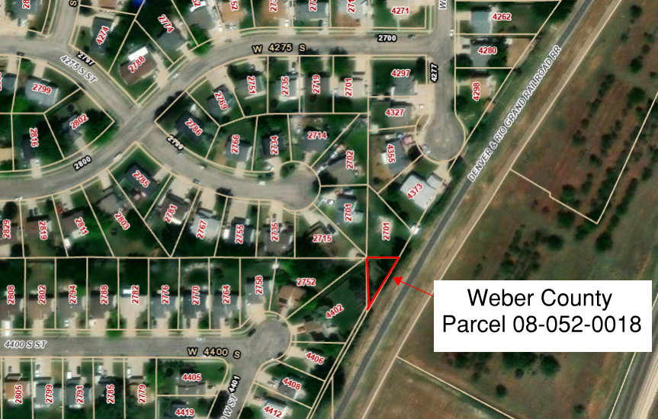

Attachment B
